Background study

The background of this dissertation explores the finding of extensive reviewing of articles, journals and web sites related to phone switching system. This section also gives an overview of experimenting with existing solution on the market. Explanations and reviews of phone switching system and its related technologies including system architecture, issue with such systems and existing solution is shown in the following paragraphs. Inline to this the background study provides a general knowledge to understand the complete dissertation.

# **Evolution of PBX**

PBX system has always played an important role in any business communication and information sharing infrastructure. The basic components of a PBX system is made of several phone lines (refer as trunks) and the physical phone itself (refer as stations). At earlier stage of the development the PBX system it was refer as PMBX (Private manual branch exchange). As the name itself demonstrate it was a totally manual system involving manual switchboard equipment. These equipment needed an operator to do the switching. Regarding this Bebusinessed.com describes the job of a switchboard operator involved answering phone calls, finding out who the caller was looking for, and plugging the phone cord into the correct jack (2015).

During this era of switchboard PBX businesses could only reply on public telephony system for internal call routing. For example calling someone in the office is the same as two person calling from different location via telephone line. Gradually companies start to invest in their own private switchboard and hire their own private switchboard operator. However not all business could afford to owned its private switchboard PBX on premises for the simple reason that the equipment were very expensive and required the hiring of switchboard operators.

While business grow and evolution of technologies the switchboard PBX system was becoming an issue and very hard to maintain for businesses. These problems are as follows:

* Expensive equipment
* Hard to maintain
* Required operators
* Not flexible
* It limited feature make it difficult to cope with the growing market.

Nevertheless many telephony system started from the switchboard PBX and the evolution of this system is shown in flowing diagram.

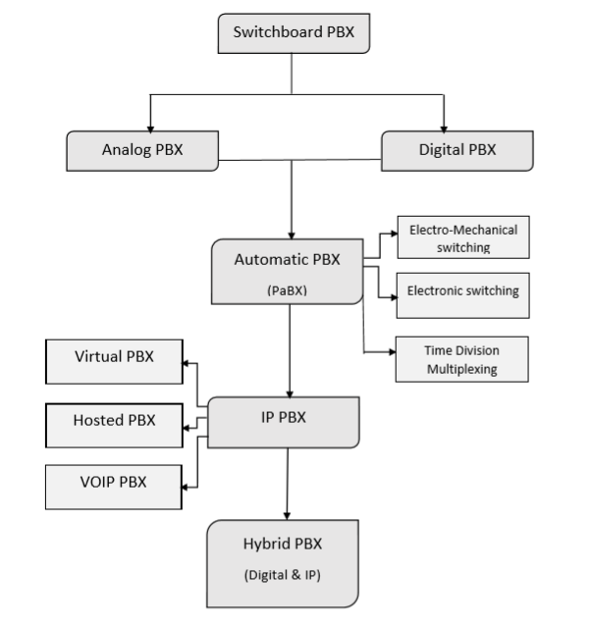

Figure _ _: The evolution of PBX system

**Analog PBX**

The analog PBX constitutes of analog phones similar to that commonly used as landline in many houses. Analog system constitute of standard copper wire for signal transmission and plain old telephone system (POTS).In simple terms the analog system is the POTS. Analog system was primarily designed switching voice and this allow to build PBX system with short call duration (Bhushan and Opderbeck, 1985, p.573). This was mainly due to the non-computerised public exchange office which had capabilities to route only voice. This was somehow a limitation of analog PBX as it could make data transmission. The evolution of public exchange started to make data transmission possible. However the telephone need to be connected to a device to convert data to voice for input and back form voice to data for output, this device was called a modem. Thus PBX handled data in the same way as the public-switched network regardless of its destination (Bhushan and Opderbeck, 1985, p.573). This system works yet has some limitations in terms of lost of voice capacities and data switching speed transmission.

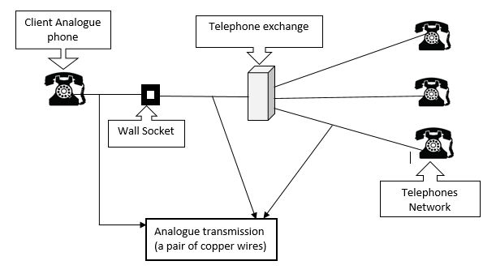

Figure _ _: A simple POTS Representation

**Digital PBX**

To be simple and short digital PBX is the digitalizing of the voice transmission. During earlier stages of PBX development, Telephone Service Corporation (1975) claims in their summary of invention that digital switching system depends on converting a telephone communications signal on an incoming line from analog to digital form, routing the digital signal to a desired outgoing line through digital switching means, and reconverting the digital signal to analog form before placing the switched signal on the outgoing line. Moreover digital switching includes two main components a stored program control and the encoding process (Junker and Noller, 1983, p.17). The encoding sample can be transmitted from a given point to another by means of binary pulses. The encoding process may take place at an analog or digital interface within the PBX or external to the system, or through appropriate manipulation of digital input signals (Junker and Noller, 1983).To make digital transmission successful over a large network the branch exchange should be computerized, which terms as computerized branch exchange or CBX . The CBX consist of operating system, applications program, static system configuration (Static tables), current system configuration (dynamic tables) and storage facilities (Pitroda, 1979, p.51).

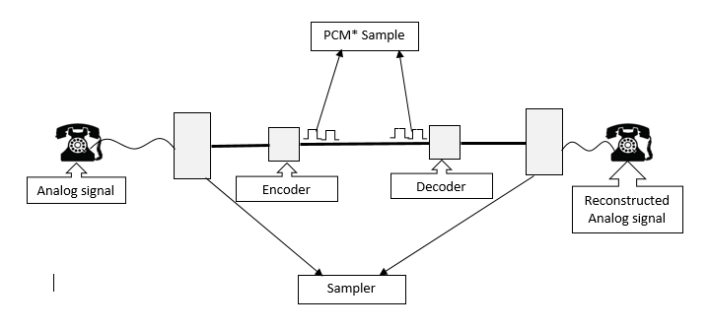

*PCM Pulse-code modulation: A voice encoding technique

Figure _ _: A basic encoding and decoding of speech signal process

According to Kasson (1979) using PCM as voice encoding technique in digital PBX has the following advantages:

* The signal is free from degradation once it is digitally encoded.
* Reconfigurations and additions can be made without changing cabinet wiring.
* The system makes economical use of digital signal processing functions.
* The system is compatible with digital transmission systems and digital terminals.
* There is no necessity for load balancing or other traffic-equalization techniques.

In addition PCM eliminate the noise and accuracy problem previously encountered by analog switching due to it digital format.

In the 1980’s the evolution of digital PBX allow the integration of voice and data communication which was the main issue with modems conversion. The modems were replaced by digital devices like digital-device data interface (DDI) (Bhushan and Opderbeck, 1985, p.573). A digital data interface device is used for transferring digital presentation data at high rate over a communication links (kabitian, 2006). The DDI can be used as a separated module for PBX equipment or can be physically integrated in the PBX station. This integration allow the PBX to handle voice and data.

## **Comparing analog switching and digital switching**

## 

|  |  |
| --- | --- |
| **Analog** | **Digital** |
| Line interfaces are simple | Line interfaces are complex due to the analog to digital conversion. |
| Difficult to install because of multistage configuration | Easy to install because of plug-in construction |
| Analog used analog amplifiers which does not eliminated noise and crosstalk. This the signal degradation is maintain. | Digital transmission signal degradation can be eliminated by using regenerative repeaters between transmitter and receiver. |
| The signal to line ratio is higher as noise generated on start of transmission are mixed with noise generated during transmission. (Gnanasivam, 2005) | Lower signal to line noise ratio due to fact that noise generated at different level of transmission can be separated by using the proper choice of code (coder decoder) (Gnanasivam, 2005) |
| No bandwidth as analog uses voice channels | Digital signal transmission need higher bandwidth.(Gnanasivam, 2005) |

Table _ _ : Comparison between analog switching and digital switching (Pitroda, 1979).

**Automatic PBX (PABX)**

PABX is the acronym for private automatic branch exchange which is the automated version of the traditional private branch exchange (PBX). A PABX is an on-premises telephone system, usually of relatively small size in comparison to telephone company exchanges, intended to service a limited number of stations (Chestel INC. 1976). For example telephone system within an office or university campus. Such system allows and control connection between various stations. It also handles outbound calls via public switch telephone network (PSTN) without need of switchboard operator. Generally the PABX system provide a station a single access to multiple lines. Ultimately the PBX is a core part of almost every telephony system available on the market today. The ‘A’ meant that the individual served by the PABX could directly dial another person on the PABX. Moreover this eventually this include calls to and from the public telephone network (Junker and Noller, 1983, p.17). More importantly advancement in switching system that has to the birth of PABX which include Electro-mechanical switching and electronic switching at earlier stages of PABX development. Likewise the evolution of digital switching with integration of Time-Division Multiplexing (TDM), circuit switching and packet switching allow the traditional PABX to evolve to meet market and business needs with additional functionalities.

**Electro-Mechanical Switching**

The PABX era started with the development of electromechanical switching system. Electromechanical switching devices can be grouped into two distinct classes (Leighton, 1966):

1. Devices which can be used to choose a specific set of contacts from a considerable number of selection, for example rotary switches.
2. Device which when operated or releases will establish or break the same set of contacts, for example relays.

The first Electromechanical was invented by Almon Strowger in the year 1889. It was then the first basic automatic telephone switch which at first could handle on two line. But is has not taken long for him to add more lines support. In the Strowger switch, pulses generated at a subscriber’s telephone directly moved electromagnetic contacts in a two-way motion in a stack of rotary contacts, thus selecting a telephone number, one digit at a time, without operator intervention (Hochheiser, 2013, p.2299). For example a subscriber needed to press a button 5 time to indicate the number 5. Using the original Strowger device was not practical enough and has been improve throughout many years by many companies. By late 60 development of semiconductor started bringing new hope of switching capabilities in PABX.

**Electronic switching**

Introduction of semiconductors to PBX allows for more reliable and faster switching. In terms of price as well it was cheaper to produce electronic switches than mechanical switches (bebusiness.com, 2015). From this point, electronic switching system gave the A in PABX its true meaning. In a patent, NEC corporation claim as object for invention of electronic switching system that to make PBX controllable from external computer by making some of the unit function in input/output processing of the switching apparatus utilizable by external computer through a computer interface. Likewise Depp and Townsend state that the electronic system has been developed to provide telephone switching service for business customers and this system is compatible with existing station (1964). Providing additional features by taking advantage of PBX is made possible by using stored program. The stored program allow a set of instruction to be stored in the machine memory. The stored program causes the machine to take predefined series of action and these instruction can be modified according to customer requirements (Depp and Townsend, 1964, p.329).

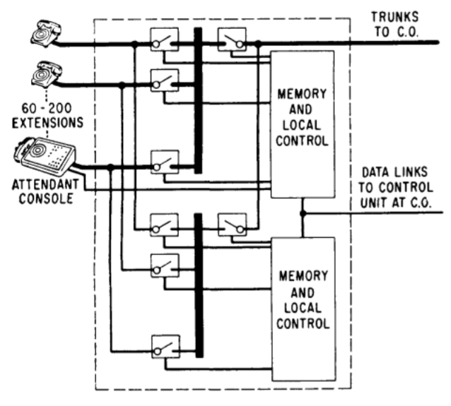

Figure _ _: No.101 ESS switch unit at customer’s premises (Depp and Townsend, 1964, p.329).

**Time Division multiplexing**

End-to-end analog telephone network were first modified in the early 1960s by upgrading network with Time Division Multiplexing (TDM) carrier system (Bakhashwain. 2011, p.339).In additional in early development of PBX, TDM technology allowed the digitization of the telephony system to meet modern business requirements. Bebusinessed.com wrote on their website that TDM allowed multiple strains of information to be conveyed over one path. Keyur et al (2007, p.2) explained TDM network dedicates a circuit with a fixed amount of bandwidth for the duration of session, regardless of its actual usage. The TDM telephony system work perfectly for voice application. However with increase business activates and requirement circuit system with TDM system was not a preferred solution. Many enterprise are migrating towards Internet Protocol (IP) based packet switched network for the primary reason to reduce the cost of transport, management and cost for equipment by having a converged network for all services (Keyur et al, 2007, p.1). Nevertheless it is possible to integrate IP based telephone system with legacy TDM equipment (Bakhashwain. 2011, p.339).

**IP PBX**

In simple word IP PBX is the merging of IP into PBX system, where IP is the Internet protocol important for nay communication over the internet. Another common terms for IP PBX is the internet telephony which is defined as the transport of telephone calls over the internet and the call can originate from traditional phone sets through gateways, PCs using software or embedded devices: refer as softphones (Wenyu Jiang et al. 2001, p.177).VOIP (voice over internet protocol) is the most used term for IP based telephony system. In comparison to traditional telephony system the voice over IP provide additional services and features. These services include conferencing, event notification, presence, instant messaging, video telephony and other multimedia transmissions (Prasad and Kumar. 2011, p.218). Similarly to traditional PBX there should be a switching system, in the case of IP- PBX it is refer as a softswitch. The softswitch provide call control and signaling services for the IP endpoints, signaling gateways, and media gateways (Ming and Jun-Zhi, 2011, p.795). It also provides signaling and media inter-working with legacy TDM voice network (Ming and Jun-Zhi, 2011, p.795). The softswitch consist of four principle layer which are as follows: Media Gateway (MG), Signaling Gateway (SG), and Features/Application Server (AS) and the softswitching.

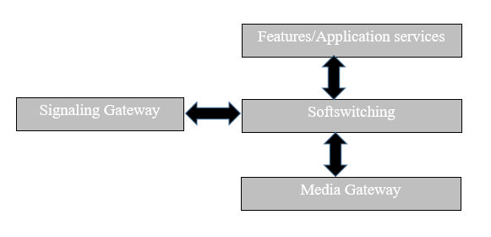

Figure_ _: Component of a softswitch architecture (Ming and Jun-Zhi, 2011, p.795).

Communication over the internet is made possible by the use of protocols. Different application uses different or a group of protocol, for example e-mail application may be using SMTP/POP3 as protocol. Likewise the main protocol use by VOIP is SIP (Session initiation protocol). SIP is an application layer signaling and control protocol for creating, modifying, and terminating session including internet telephone calls, multimedia distribution and multimedia conferences (Prasad and Kumar. 2011, p.218). At its core the SIP architecture is similar to HTTP which follows a text-based client-server protocol. The SIP architecture consist of the following logical components as describe by Prasad and Kumar (2011, p.218):

User Agents (UA), SIP Proxy, SIP Registrar, SIP Redirect Server, Location Server and Media Gateway. The UA are usually soft-phone or IP- phone.

In the same as HTTP has verbs or message like GET and POST, SIP also has its own messages or methods dealing with Client request and server responses. The main request methods are defined in the RFC 3261 which are: INVITE, ACK, BYE, CANCEL, REGISTER, OPTIONS. There other methods like INFO, PRACK, UPDATE, REFER, SUBCRIBE, NOTIFY, MESSAGE AND PUBLISH (Prasad and Kumar. 2011, p.218). However each device connect to a IP-PBX network is identified by the extension number which correspond and IP address but often refer it its owner name than the extension number itself.

|  |  |  |
| --- | --- | --- |
| User Name | User Extension | IP Address |
| John | 100 | 192.168.10.22 |
| Mary | 101 | 192.168.10.12 |
| Mervin | 102 | 192.168.10.40 |

Table _ _ : Example of Extension Number and IP address in IP-PBX

The IP- PAX architecture basically follows a three- tier architecture as its can be divided into three layers as follows: Service layer, Control layer and Access layer.

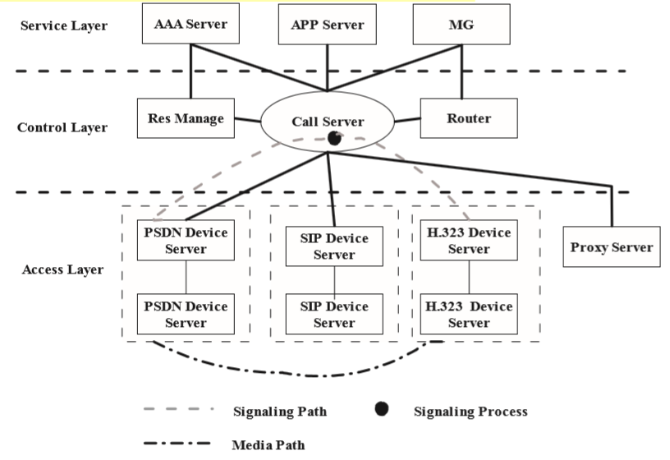

Figure _ _: A typical architecture of IP- PBX (Ming and Jun-Zhi, 2011, p.796).

An enterprise does not need to buy and install all equipment on premises to set a PBX system. The enterprise can subscribe to a PBX service provider, this concept is describe as Hosted PBX whereby all installation is found at a service provider location and a customer connect via IP to uses PBX features. Another common reference for such system is Virtual PBX. Customer can chose between different packages provided by different companies. However the enterprises should have their SIP user agent which can be an IP phone or softphone. Today’s there are many softphones available on the market which uses very easy to used and has very intuitive user interface. The following are example of popular softphones: Zoiper, 3cx, XLite and Twinkle. Most of the example mention above run of all desktop platforms and mobile platform except for twinkle which is for Linux users. Features of these softphones is pretty much the same such as audio calls, video calls, test messaging, faxes option, recording, call history and other features. Customer has a large palette of virtual PBX phone systems such as Grasshopper, evoice, virtual PBX and ONSIP. However there are two more company which are much more than just a PBX service provider they are Twilio and Plivo. These companies provide a framework that developer may use to integrate telecommunication features to their application or web site. This is made possible by the available VIOP SDK’s, API and XML content. In addition both companies provide cloud based telephony system. In the other hand to if a developer wants to develop a PBX system there are two major open source telephony platform available name Freeswitch and Asterisk. The two platform is the most popular soft switch available for development and many companies telephony system is based on these platform.

**Freeswitch**

The latest Freeswitch release is the version 1.6 and is recommended by Freeswitch team to use this version for production which is explained by Brain West (2015) on the Freeswitch website. Freeswitch is a scalable open source cross-platform telephony platform designed to route and interconnect popular communication protocols. It was designed and implemented by Anthony Minessale with help of brain west and Michael Jerris. Freeswitch has a large and active development community, mailing list, an IRC channel, an annual convention, and a weekly conference calls hosted on an instance of freeswitch. Freeswitch is licensed under the MPL. Mozilla Public License. There two book available for understanding and implementing freeswitch, these are the Freeswitch 1.6 cookbook and Freeswitch 1.2.

A telephony system or PBX has many features and functionalities, Freeswitch support most of the features associated with such system which are as follows (Minessale et al. 2012, p.93):

* Creating users
* Accessing voicemail
* The company directory
* Using phrase macros to build sound prompts
* Creating XML IVR menus f Music on hold
* Creating conferences
* Sending faxes
* Receiving faxes
* Basic text-to-speech with mod_flite
* Advanced text-to-speech with mod_tts_commandline
* Recording calls

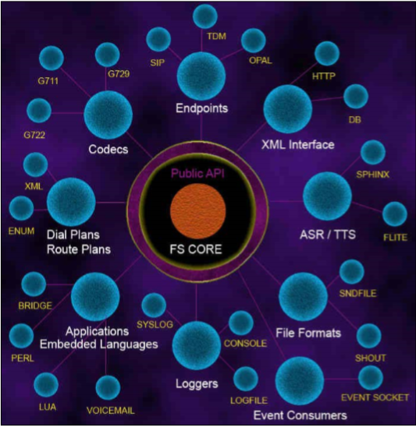

Figure _ _ : Freeswitch Architecture and modules associated (Minessale et al. 2010, p.33).

**Asterisk**

**References:**

Chestle INC., 1976.*Electronic time-division-multiplexed pabx telephone system*. United States patent application 3937892 A.

# Bebusinnessed.com. (2015) *History of PBX* [Online] Available at: <http://bebusinessed.com/history/history-of-pbx/> [Accessed: 2nd December 2015].

Bhushan, B. and Opderbeck, H. 1985. The Evolution of Data Switching for PBX’s. *IEEE Journal on Selected Areas in Communications*.3 (1). 569-573.

Telephone Service Corporation., 1975*. Digital telephone switching system.* United States patent application US3889067 A.

Junker S.L and Noller W.E., 1983. Digital private branch exchanges*.* *Communications Magazine, IEEE.* 23 (3), 11-17.

Pitroda, S.G. (1979). Telephones go digital: Lower cost, higher performance and greater flexibility favor the digital approach over analog switching. IEEE Spectrum Magazine. 16(10), 51-55.

Kasson, J.M. (1979). Survey of digital PBX design. IEEE Transactions on Communications. 27 (7), 1118-1124.

[Behnam Katibian](http://www.google.com/search?tbo=p&tbm=pts&hl=en&q=inassignee:%22Behnam+Katibian%22), [Wiley George A](http://www.google.com/search?tbo=p&tbm=pts&hl=en&q=inassignee:%22Wiley+George+A%22), [Brian Steele](http://www.google.com/search?tbo=p&tbm=pts&hl=en&q=inassignee:%22Brian+Steele%22)., 2006. *Digital data interface device*. United States patent application US 20060288133 A1.

Gnanasivam, P., 2005. *Telecommunication switching and networks.* New Delhi: New age international (P) ltd.

Leighton, A.G., 1966. Electromechanical switching devices: reliability. Life and the relevance of circuit design. *Radio and Electronic Engineer,* 31(2), 99-109.

Hochheiser, S., 2013. STARS: Electromechanical Telephone Switching [Scanning Our Past]. *Proceedings of the IEEE*, 101(10), 2299-2305.

Nec Corporation., 1990. *Electronic switching system connected to an external computer*. United States patent application US4928304 A.

Depp, W.A, and Townsend, M.A. 1964. An Electronic-Private-Branch-Exchange Telephone Switching System. *Communication and Electronics*, 83 (73), 329-331.

Bakhashwain, M.J., 2011. A case study on the road to IP telephony: A company’s strategic decision to move toward the next-Generation Network. *Technology Management Conference (ITMC), 2011 IEEE International,*37-30 June 2011 San Jose, CA. IEEE, 338-345.

Parikh, Keyur, Kim and Junius., 2007. TDM Services over IP Networks. [*Military Communications Conference. MILCOM 2007. IEEE*](http://ieeexplore.ieee.org/xpl/mostRecentIssue.jsp?punumber=4454732)*, 29-31 October 2007 Orlando, FL, USA. IEEE, 1-10.*

Wenyu jiang, Jonathan Lennox, Henning Schulzrinne, Kundan Singh., 2001. Towards the junking of the PBX: deploying IP telephony*. In: Jason Nieh, NOSSDAV '01 Proceedings of the 11th international workshop on Network and operating systems support for digital audio and video*. New York: ACM, 177-185.

# Prasad, J.k. and Kumar, B.A., 2011. Analysis of dip and realization of advanced IP-PBX features. *Electronics Computer Technology (ICECT), 2011 3rd International Conference, 8-10 April 2011Kanyakumari*. IEEE, 218-222.

Ming, S. and Jun-Zhi, Y., 2011. Design and implementation of IP PBX architecture based on V5 interface. *Electronics Computer Technology (ICECT), 2011, International Conference, 9-11 September 2011 Ningbo.* IEEE, 795-797.

West, B., 2015. *Freeswitch explained* [online]. Available from: <https://freeswitch.org/confluence/display/FREESWITCH/FreeSWITCH+Explained> [Accessed 21 December 2015].

Minessale, A., Collins, M.S and Marruzzelli, G., 2012. *Freeswitch 1.3 cookbook*. 2nd ed. Birmingham: Packt Publishing Ltd.

Minessale, A., Collins, M.S., Schreiber, D. and Chandler, R. 2010. *Freeswitch 1.2.* 2nd ed. Birmingham: Packt Publishing Ltd.